Name – Harshad Khedekar
Email – harshadkhedekar123@gmail.com

1. What does the dollar($) sign do?
- In Excel, a dollar sign can denote a currency format, but it has another common use: indicating absolute cell references in formulas
- If you want to display numbers as monetary values, you must format those numbers as currency. To do this, you apply either the Currency or Accounting number format to the cells that you want to format. The number formatting options are available on the Home tab, in the Number group.

2. How to Change the Reference from Relative to Absolute (or Mixed)?

- To change the reference from relative to absolute, you need to add the dollar sign before the column notation and the row number.
- For example, A1 is a relative cell reference, and it would become absolute when you make it $A$1.
- If you only have a couple of references to change, you may find it easy to change these references manually. So you can go to the formula bar and edit the formula (or select the cell, press F2, and then change it).
- However, a faster way to do this is by using the keyboard shortcut – F4.
- When you select a cell reference (in the formula bar or in the cell in edit mode) and press F4, it changes the reference.
- Suppose you have the reference =A1 in a cell.
- Here is what happens when you select the reference and press the F4 key.
- Press F4 key once: The cell reference changes from A1 to $A$1 (becomes ‘absolute’ from ‘relative’).
- Press F4 key two times: The cell reference changes from A1 to A$1 (changes to mixed reference where the row is locked).
- Press F4 key three times: The cell reference changes from A1 to $A1 (changes to mixed reference where the column is locked).
- Press F4 key four times: The cell reference becomes A1 again.

3. Explain the order of operations in excel?
Calculation order
- Formulas calculate values in a specific order. A formula in Excel always begins with an equal sign (=). Excel interprets the characters that follow the equal sign as a formula. Following the equal sign are the elements to be calculated (the operands), such as constants or cell references. These are separated by calculation operators. Excel calculates the formula from left to right, according to a specific order for each operator in the formula.
Operator precedence in Excel formulas
- If you combine several operators in a single formula, Excel performs the operations in the order shown in the following table. If a formula contains operators with the same precedence—for example, if a formula contains both a multiplication and division operator—Excel evaluates the operators from left to right.
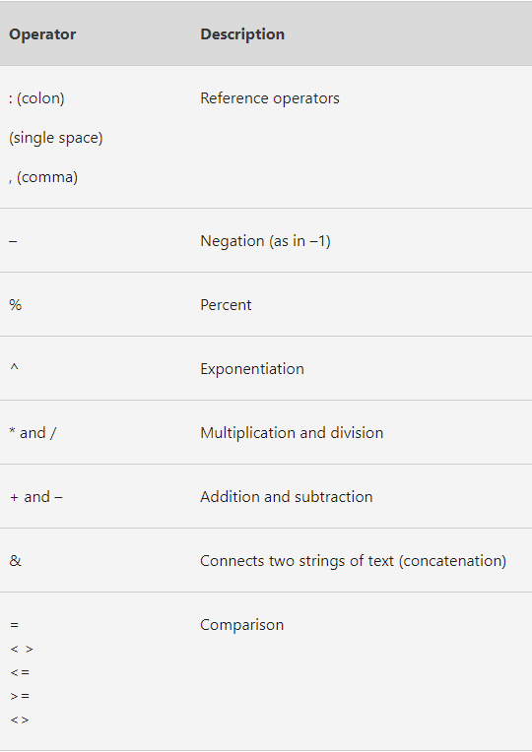
When evaluating a formula, Excel follows a standard math protocol called "order of operations". In general, Excel's order of operation follows the acronym PEMDAS (Parentheses, Exponents, Multiplication, Division, Addition, Subtraction) but with some customization to handle the formula syntax in a spreadsheet.
Excel solves formulas in the following order:
- Parentheses
- Reference operators
- Exponents
- Negation
- Percent
- Multiplication and Division
- Addition and Subtraction
- Concatenation
- Logical operators

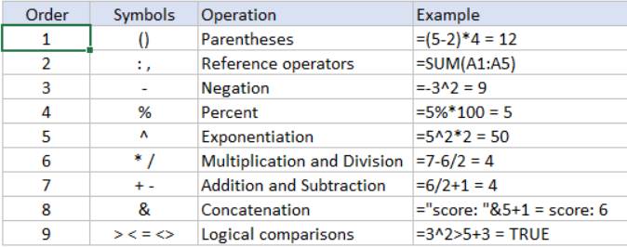

4. What, according to you, are the top 5 functions in excel and write a basic syntax for any of two?
- SUM
Syntax = SUM(number1, number2, )

- AVERAGE
Syntax = AVERAGE(number1, number2, )

- COUNT
Syntax = COUNT(value1, value2, )

- COUNTA
Syntax = COUNTA (number 1, number 2, …)

- MAX
Syntax = MAX(number1, number2, ….)

5. When would you use the subtotal function?
- The SUBTOTAL function is used when you display a Total row in an Excel Table. Excel inserts the SUBTOTAL function automatically, and you can use a drop-down menu to switch behavior and show max, min, average, etc.
- Excel uses SUBTOTAL for calculations in the Total row of an Excel Table because SUBTOTAL automatically excludes rows hidden by the filter controls at the top of the table. That is, as you filter rows in a table with a Total row, calculations automatically respect the filter.
- The Excel SUBTOTAL function returns an aggregate result for supplied values. SUBTOTAL can return a SUM, AVERAGE, COUNT, MAX, and others, and SUBTOTAL function can either include or exclude values in hidden rows.
- Syntax = SUBTOTAL (function_num, ref1, [ref2], ...)

6. What is the syntax of the vlookup function? Explain the terms in it?
- Syntax =VLOOKUP(lookup value, range containing the lookup value, the column number in the range containing the return value, Approximate match (TRUE) or Exact match (FALSE)).
- In its simplest form, the VLOOKUP function says:
- =VLOOKUP(What you want to look up, where you want to look for it, the column number in the range containing the value to return, return an Approximate or Exact match – indicated as 1/TRUE, or 0/FALSE).
- Use VLOOKUP when you need to find things in a table or a range by row. For example, look up a price of an automotive part by the part number, or find an employee name based on their employee ID.
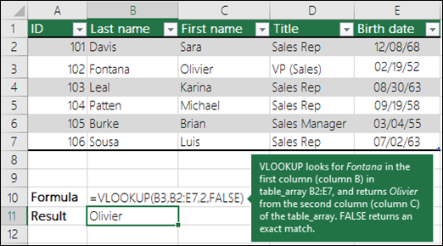

There are four pieces of information that you will need in order to build the VLOOKUP syntax:
- The value you want to look up, also called the lookup value.
- The range where the lookup value is located. Remember that the lookup value should always be in the first column in the range for VLOOKUP to work correctly. For example, if your lookup value is in cell C2 then your range should start with C.
- The column number in the range that contains the return value. For example, if you specify B2:D11 as the range, you should count B as the first column, C as the second, and so on.
- Optionally, you can specify TRUE if you want an approximate match or FALSE if you want an exact match of the return value. If you don't specify anything, the default value will always be TRUE or approximate match.

